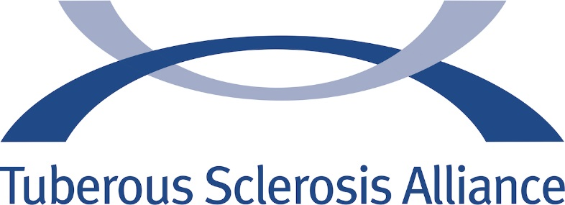

KEITH HALL DISTINGUISHED LEADER AWARDS

2017
Kathy Henkel
2018
Jennifer Waldron

