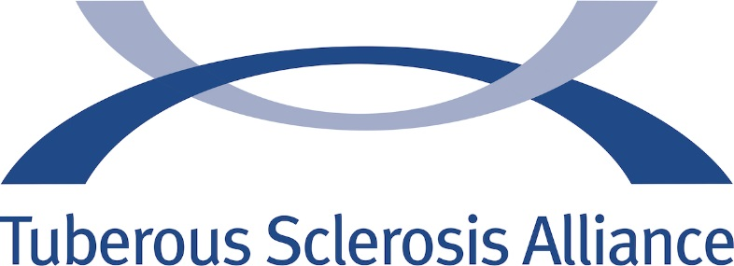

COMMUNITY ALLIANCE OF THE YEAR WINNERS

2007
TS Alliance of Georgia

2008
TS Alliance of the Upper Midwest

2009
TS Alliance of the Rocky Mountain Region

2010
TS Alliance of Indiana

2011
TS Alliance of Greater Kansas City

2012
TS Alliance of New England

2013
TS Alliance of Ohio

2014
TS Alliance of Greater Chicago

2015
TS Alliance of Connecticut

2016
TS Alliance of the Upper Midwest

