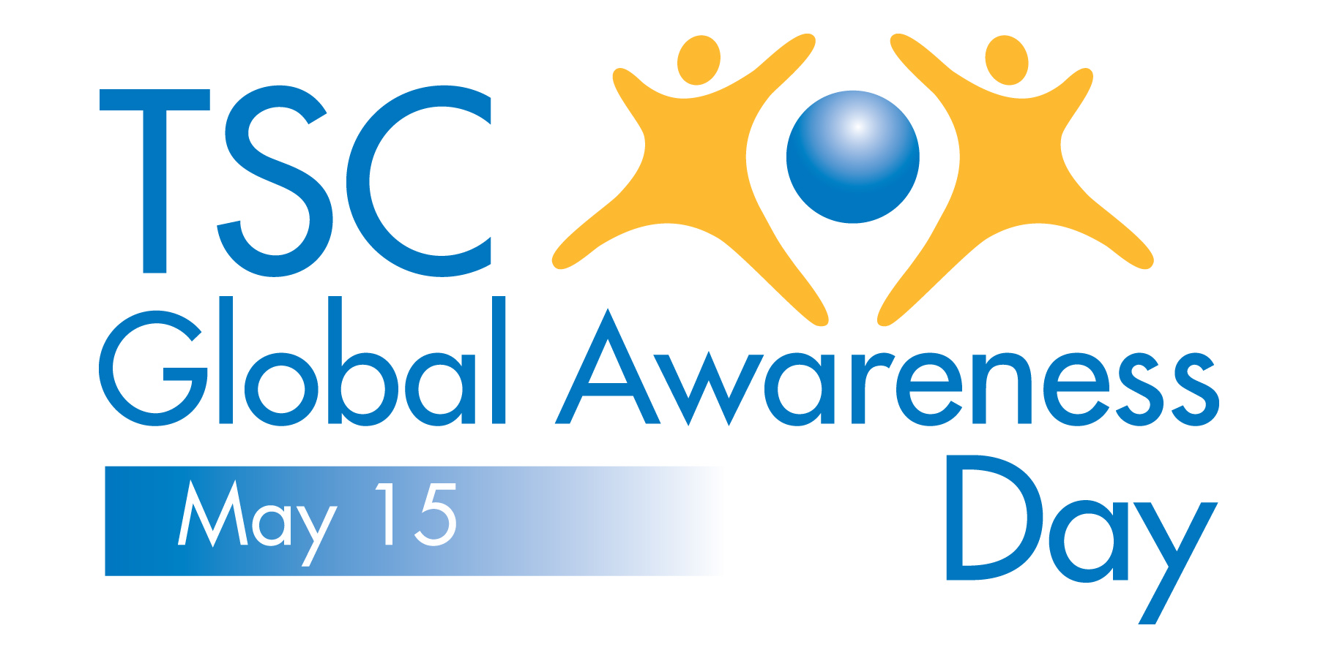

SAMPLE TSC GLOBAL AWARENESS DAY TWEETS

Simply copy/paste the following tweet suggestions to your Twitter account to help increase awareness about tuberous sclerosis complex among all your Twitter followers.

For Individuals, Organizations and Governmental Agencies

- May 15 is TSC Global Awareness Day. Tuberous sclerosis complex affects 1 million worldwide. Join the fight at http://bit.ly/ZRxBdI #tsc
- TSC Global Awareness Day is May 15. There is no cure for tuberous sclerosis complex--yet. Join the fight at http://bit.ly/ZRxBdI #tsc
- TSC Global Awareness Day is May 15. Please help spread the word with a RT and join the fight at http://bit.ly/ZRxBdI #tsc #raredisease

