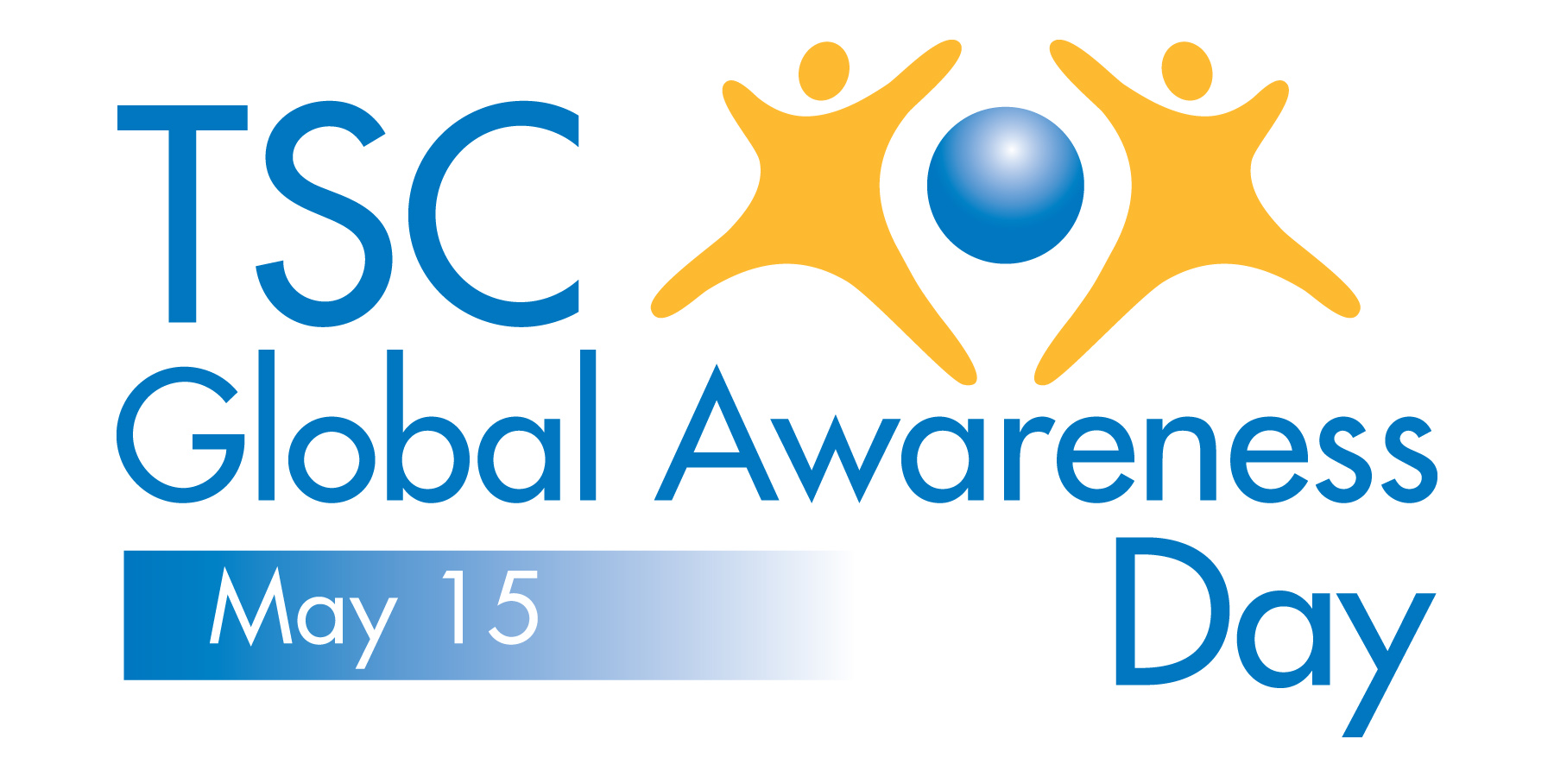

SAMPLE TSC GLOBAL AWARENESS DAY FACEBOOK POSTS

Simply copy/paste the following text examples to your Facebook wall to help increase awareness about tuberous sclerosis complex among all your Facebook friends and followers.

For Individuals

- May 15 is TSC Global Awareness Day – 1 million people worldwide have tuberous sclerosis complex (TSC<) including <INSERT NAME OF PERSON WITH TSC>. TSC causes tumors to form in vital organs like the brain, kidneys, heart, lungs, eyes and skin. There is no cure, but research is helping find new and better treatments. Please share to show your support of <INSERT NAME OF PERSON WITH TSC>. http://www.tscglobalday.org
- May 15 is TSC Global Awareness Day. <INSERT NAME OF PERSON WITH TSC> has tuberous sclerosis complex (TSC) and is hoping for a better future for everyone affected by the disorder. TSC is the leading genetic cause of both epilepsy and autism. Please support <INSERT NAME OF PERSON WITH TSC> by sharing this post to help spread awareness. http://www.tscglobalday.org
- Please help <INSERT NAME OF PERSON WITH TSC> fight tuberous sclerosis complex (TSC) on May 15 – TSC Global Awareness Day. Simply share this post and ask your friends to visit http://www.tscglobalday.org.
For Organizations and Governmental Agencies
- May 15 is TSC Global Awareness Day. <INSERT NAME OF ORGANIZATION> is proud to be a partner in the fight against tuberous sclerosis complex (TSC), a devastating genetic disease affecting 1 million people worldwide. Find out more at http://www.tscglobalday.org.
- <INSERT NAME OF ORGANIZATION> is proud to partner in the fight against tuberous sclerosis complex (TSC) by helping mark TSC Global Awareness Day on May 15. TSC is a rare genetic disease that causes tumors to form in vital organs, like the brain, kidneys, heart, lungs, eyes and skin. TSC is also the leading genetic cause of both epilepsy and autism. Help us increase increase awareness by visiting http://www.tscglobalday.org.

