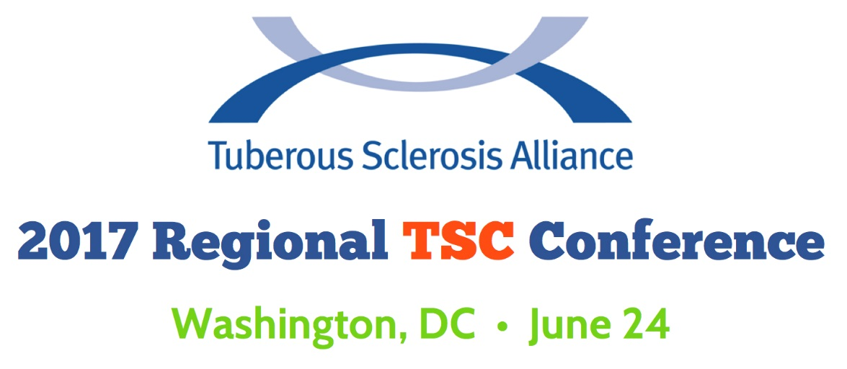
Agenda
June 24, 2017 – Washington, DC

9 – 9:30 a.m. Check-in/Registration

9:30 – 10:45 a.m. Welcome and Opening General Session: Research and Upcoming Clinical Trials
Moderator: Kari Luther Rosbeck, President and CEO, TS Alliance Speakers: Kari Luther Rosbeck, President and CEO, TS Alliance; Elizabeth Thiele, MD, PhD; Darcy Krueger, MD, PhD

10:45 a.m. Break

11 a.m. – 12 p.m. Track 1: TSC Pediatric: Seizure Types and Treatments
Moderator:
Speakers: Darcy Krueger, MD, PhD

Track 2: TSC Adult: Epilepsy and Current Treatments
Moderator:
Speakers: Elizabeth Thiele, MD, PhD

12:00 – 1:00 p.m. LUNCH

1:00 – 1: 45 p.m. Track 1: TSC Pediatric: ADHD and Behavioral Challenges
Moderator:
Speakers: Tanjala Gipson, MD

Track 2: TSC Transition Age: Transitioning Medical Care, Guardianship and Special Needs Trusts
Moderator:
Speakers: Claudio De Gusmao, MD; Kelly Piacenti

Track 3 (Joint with LAMposium): Renal Involvement in TSC and LAM
Moderator:
Speakers: John Bissler, MD

2:00 – 2:45 p.m. Track 1: TSC Pediatric: Autism Spectrum Disorder and Therapeutic Options
Moderator:
Speakers: Tanjala Gipson, MD

Track 2: TSC Transition Age: Education, Employment and Housing
Moderator:
Speakers: Shawn Ullman

Track 3 (Joint with LAMposium): Dermatology and Genetics
Moderator:
Speakers: Thomas Darling, MD, PhD; Joel Moss, MD, PhD

2:45 – 3 p.m. BREAK

3 – 4:30 p.m. General Session Joint with International Research Conference: Researchers in TSC and LAM
Moderator:
Speakers:

Sponsored By:

