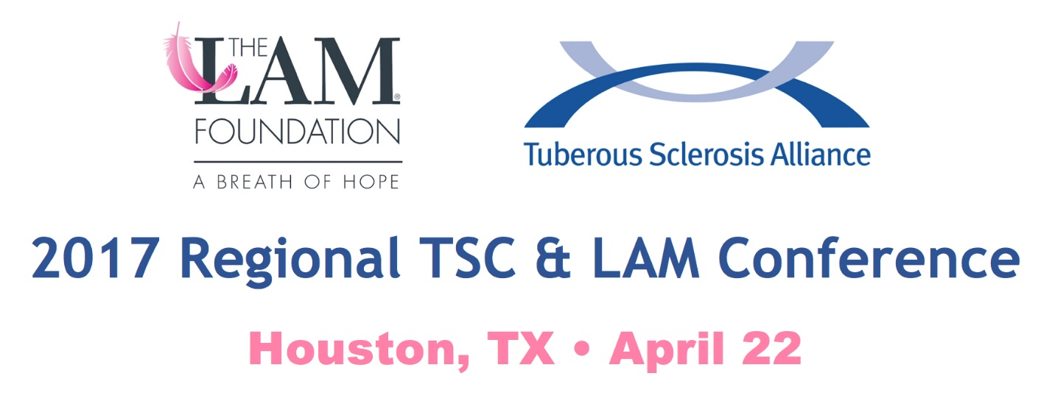

Regional TSC & LAM Conference Agenda
(As of February 21, 2017; subject to change)

April 22, 2017
Texas Training and Conference Centers
11490 Westheimer Rd, Suite 600
Houston, TX 77077

8:30 – 9:30 a.m. Check-in/Registration

9:30 – 10:45 a.m. Welcome and Opening General Session: Research and Upcoming Clinical Trials
Moderator: Steven L. Roberds, PhD, Chief Scientific Officer, TS Alliance
Speakers: Kari Luther Rosbeck, President and CEO, TS Alliance; Anne McKenna, MBA, Patient Services and Education Manager, The LAM Foundation; Hope Northrup, MD; Howard L. Weiner, MD

10:45 – 11 a.m. Break

11 a.m. – 12 p.m. Track 1: TSC Pediatric: Seizure Types and Treatments
Moderator: Howard Weiner, MD
Speakers: Rohini Coorg, MD, Dr. Mary Kay Koenig, MD, Daniel J. Curry, MD

Track 2: TSC Adult: Epilepsy and Current Treatments
Moderator: Jake Irby, Adult Regional Coordinator, TS Alliance
Speakers: Deborah E. Briggs, MD

Track 3: LAM Specific General Session
Moderator: Kathi Hawn, LAM Liaison
Speakers: Rosa M. Estrada-Y-Martin, MD

12 – 1 p.m. LUNCH

1 – 1: 45 p.m. Track 1: TSC Pediatric: ADHD and Behavioral Challenges
Moderator: Jo Anne Nakagawa, Director of Clinical Projects and TSC Clinic Liaison
Speaker: Tanjala T. Gipson, MD

Track 2: TSC Transition Age: Transitioning Medical Care
Moderator: Jake Irby, Adult Regional Coordinator, TS Alliance
Speaker: Rebecca J. Schultz, PhD, RN, CPNP
Track 3: TSC Adult/LAM: Rapamune, Drug Treatment for LAM
Moderator: Kathi Hawn, LAM Liaison
Speaker: Denisse Martinez, PharmD, RPh

1:45 – 2 p.m. Break

2 – 3 p.m. Track 1: TSC Pediatric: Autism Spectrum Disorder and Therapeutic Options
Moderator: Jo Anne Nakagawa, Director of Clinical Projects and TSC Clinic Liaison
Speaker: Tanjala Gipson, MD; Deborah Pearson, PhD

Track 2: TSC Transition Age: Education, Employment and Housing
Moderator: Jake Irby, Adult Regional Coordinator, TS Alliance
Speaker: Morgan Zeringue, MSW

Track 3: TSC Adult/LAM: Kidneys and Angiomyolipomas
Moderator: Jake Irby, Adult Regional Coordinator, TS Alliance
Speaker: Joshua A. Samuels, MD, MPH

3 – 3:15 p.m. BREAK

3:15 – 4 p.m. General Session: Genetics in TSC and LAM
Moderator: Steve Roberds, PhD
Speaker: Hope Northrup, MD

Sponsored By:

